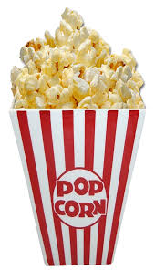
Popcorn popping in the pan
There’s popcorn popping in the pan,
There’s popcorn popping in the pan,
There’s popcorn popping, popcorn popping, there’s popcorn popping in the pan!

There’s jelly wobbling on a plate,
There’s jelly wobbling on a plate,
There’s jelly wobbling, jelly wobbling, there’s jelly wobbling on a plate!

There’s ice-cream melting on the floor,
There’s ice-cream melting on the floor,
There’s ice-cream melting, ice-cream melting, there’s ice-cream melting on the floor!

Horsey Horsey
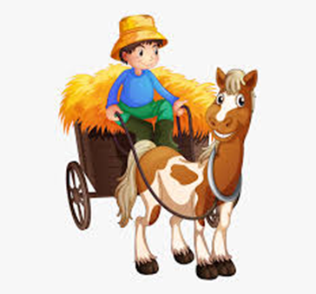
Horsey horsey don’t you stop,
Just let your feet go cliperty clop,
Your tail goes swish and the wheels go round,
Giddy up we’re homeward bound!

Wind the bobbin up
Wind the bobbin up, wind the bobbin up,
Pull pull, clap clap clap,
Wind it back again, wind it back again,
Pull pull, clap clap clap,
Point to the ceiling, point to the floor, point to the window, point to the door, clap your hands together one, two three, put your hand upon your knees! 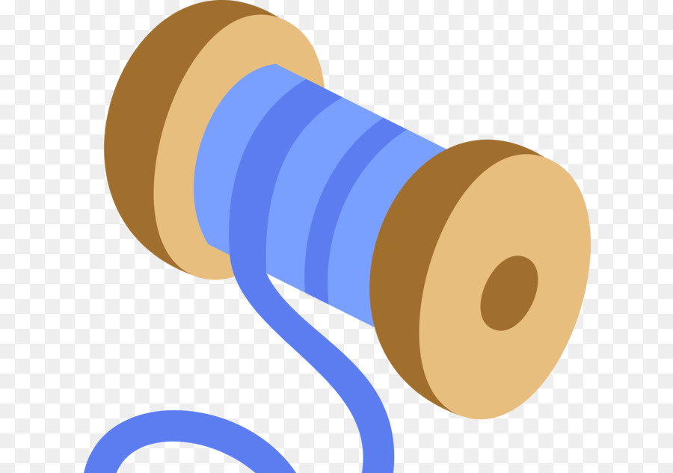

Five little men
Five little men in a flying saucer, flew round the world one day, they looked left and right but they didn’t like the sight so one man flew away, whoosh!
Four little men…….
Three little men….
Two little men……
One little man in his flying saucer, flew round the world one day, he looked left and right and he really liked the sight so he decided to stay!
