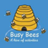
This term at Busy Bees
Pre-school……
Activities
Just a taste of what your child will have the opportunity to do over the coming weeks….
- Learn new songs supporting language development.
- Explore a range of craft materials including different papers, glue, glitter and cotton wool. This promotes fine motor development as well as creativity.
- Large scale painting & junk modelling
- Dressing up
- Music and dance
- During December we shall embrace Christmas and explore the different ways we all celebrate.

To support learning at home you might like to…….
Sing songs together which we sing in preschool. Please find attached the words to some of the songs we sing most frequently. In December we shall send out the Christmas song sheet so you can join in with those too!
Practice the magic coat trick! https://www.youtube.com/watch?v=-FaxBoCvNqM gives a demonstration. You put the coat upside down with the hood at their feet. Encourage your child to put their arms in and flip the coat over their head into position.

Skills we are promoting…..
As we head into winter we are learning to put our own coats on. Doing things for ourselves boosts self-esteem and supports independence.
This term our focus is creativity. We are exploring different craft materials and forms of expression, such as music and dance.
This term is full of festivals and celebrations, including Christmas! All children will have the opportunity to widen their experiences and engage in creative activities which support many areas of learning including Communication and language, Understanding the world and Expressive arts and design.

For more information about our curriculum, the EYFS and how you can help your child at home please visit our website www.busybeespreschool.org.uk or www.foundationyears.org.uk
We love hearing all about your learning at home. You can email photos to enquiries@busybeespreschool.org.uk

Popcorn popping in the pan
There’s popcorn popping in the pan,
There’s popcorn popping in the pan,
There’s popcorn popping, popcorn popping, there’s popcorn popping in the pan!

There’s jelly wobbling on a plate,
There’s jelly wobbling on a plate,
There’s jelly wobbling, jelly wobbling, there’s jelly wobbling on a plate!

There’s ice-cream melting on the floor,
There’s ice-cream melting on the floor,
There’s ice-cream melting, ice-cream melting, there’s ice-cream melting on the floor!

Horsey Horsey
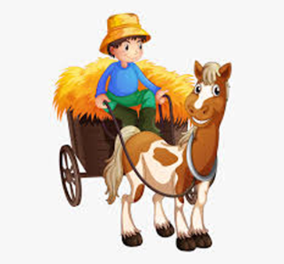Horsey horsey don’t you stop,
Just let your feet go cliperty clop,
Your tail goes swish and the wheels go round,
Giddy up we’re homeward bound!

Wind the bobbin up
Wind the bobbin up, wind the bobbin up,
Pull pull, clap clap clap,
Wind it back again, wind it back again,
Pull pull, clap clap clap,
Point to the ceiling, point to the floor, point to the window, point to the door, clap your hands together one, two three, put your hand upon your knees!

Five little men
Five little men in a flying saucer, flew round the world one day, they looked left and right but they didn’t like the sight so one man flew away, whoosh!
Four little men…….
Three little men….
Two little men……
One little man in his flying saucer, flew round the world one day, he looked left and right and he really liked the sight so he decided to stay!
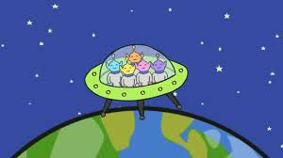

Popcorn popping in the pan
There’s popcorn popping in the pan,
There’s popcorn popping in the pan,
There’s popcorn popping, popcorn popping, there’s popcorn popping in the pan!

There’s jelly wobbling on a plate,
There’s jelly wobbling on a plate,
There’s jelly wobbling, jelly wobbling, there’s jelly wobbling on a plate!

There’s ice-cream melting on the floor,
There’s ice-cream melting on the floor,
There’s ice-cream melting, ice-cream melting, there’s ice-cream melting on the floor!

Horsey Horsey
Horsey horsey don’t you stop,
Just let your feet go cliperty clop,
Your tail goes swish and the wheels go round,
Giddy up we’re homeward bound!

Wind the bobbin up
Wind the bobbin up, wind the bobbin up,
Pull pull, clap clap clap,
Wind it back again, wind it back again,
Pull pull, clap clap clap,
Point to the ceiling, point to the floor, point to the window, point to the door, clap your hands together one, two three, put your hand upon your knees!

Five little men
Five little men in a flying saucer, flew round the world one day, they looked left and right but they didn’t like the sight so one man flew away, whoosh!
Four little men…….
Three little men….
Two little men……
One little man in his flying saucer, flew round the world one day, he looked left and right and he really liked the sight so he decided to stay!

