Term 6 Newsletter; June 2021
Busy Bees Preschool
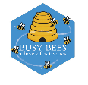
Charity no; 1014692

Upcoming Events & Important dates

School leavers parents chats-
Friday 25th June

School Leavers celebrations- more details to follow soon
Friday 16th July, 12-2pm

If you need any information about funding go to www.childcarechoices.gov.uk

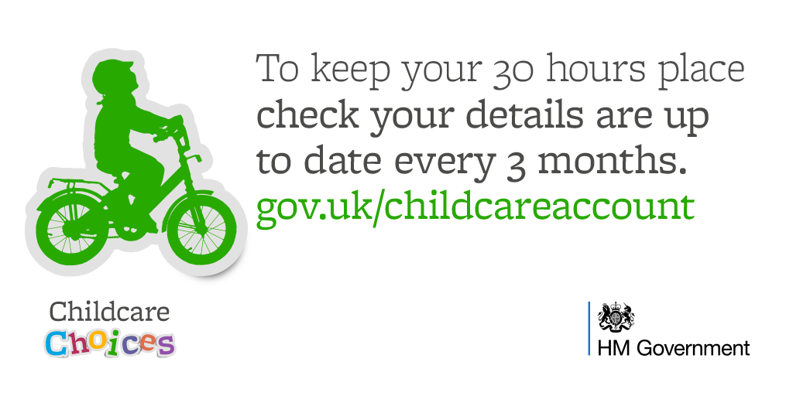

Welcome back everyone, we hope you enjoyed the half term break.

A term for transition, only 6 weeks to go…
This term we say goodbye to all 30 of our preschool children who will be going off to Reception class in September. What a busy busy year it has been!!

The children will be preparing to go to school this term by learning in their school groups, having visits from reception teachers (fingers crossed) and also having inductions at their relevant schools. We will also be sending parents an information booklet about – ‘Preparing for Primary’ full of useful tips and advice
Please note we are unable to change your child’s sessions if they coincide with school visits.

Fundraising event- sponsored 10km walk
As a charity run preschool raising funds to help towards resources and additional events or experiences for the children is extremely important, however fundraising during the last year has been a challenge to say the least. We are now in the position to organise an event that all the children can get involved with. Our aim is to complete a 10km sponsored walk in the local community consisting of short manageable laps for the children.
More details will follow next week, along with a sponsor form…it goes without saying that all funds raised will really be appreciated. Our target is £200.00 which will be used towards

General Information
Also…
- With the hope of some warmer weather please ensure your child has a named hat in Preschool. Children are required to have sun-cream applied before coming to Busy Bees. We strongly recommend a once a day sun-cream, alternatively please provide Busy Bees with a high factor sun-cream that can be reapplied at lunchtime.
- Please also ensure that children have jackets/coats as the weather is so changeable at the moment- and we only have a couple of spares
- Just a reminder about toys from home. Children should not bring any kind of toys or gadgets into preschool, so please ensure they are kept at home.
- Sessions for September; please book your child sessions for September asap. Both 8.30 starts and 4 o’clock club can be used as part of funded hours if booked. Once hours have been claimed for at the beginning of term you are unable to increase hours until the start of the following term- January April or September.
- Therefore, if you are applying for the 30 hour funding for your child for September, you need to apply in June/July and inform the preschool of the 30 hour code and book hours accordingly, before the end of term. If you apply in September the additional funding will be available from January.
- For details of funding including 30 hour criteria go to www.childcarechoices.gov.uk

How you can help us
During your child’s time at Busy Bees you will not be asked to pay for additional activities and experiences, however there are lots of ways you can support the preschool;

Donations of snacks;
- Savoury biscuits such as crackers, digestive rich tea & cheddars
- Fruit & vegetables
- Rice cakes
- Dried fruit
- Cheese
- Large pots of yoghurt
Cash donation area also welcomed and will be used to towards snacks or resources for the children.
Thank you for your support, it makes a big difference & is really appreciated

