Term 3 Newsletter; January 2021
Busy Bees Preschool
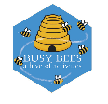
Charity no; 1014692

Upcoming Events & Important dates

Last day of term 3;
Friday 12th February

1st day of term 4;
Monday 22nd February

Mon 8th – Fri 12th March
- Telephone consultations with your child’s Key Person- more details follow

The Preschool will be closed on Monday 7th June 2020
for staff training

If you need any information about funding go to www.childcarechoices.gov.uk

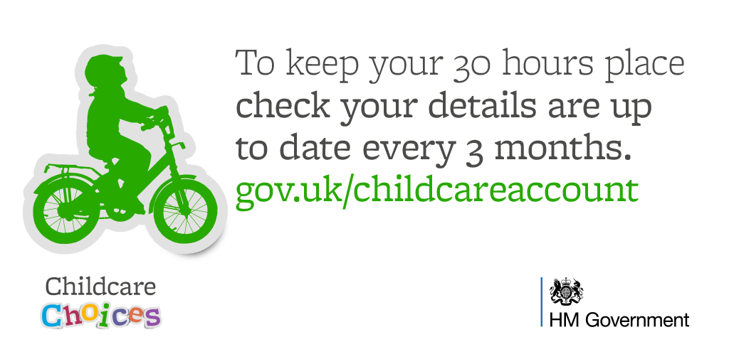
Welcome back everyone and a happy new year to you all, we hope you enjoyed the Christmas holidays.
A special welcome to our new families this term.
Although this has not been the start to the term that we hoped for, due to the positive case, we would like to thank parents for their understanding and support.
We are open this week for children and staff, who were not affected
Your child’s, and the staff teams health and well being is our number one priority, and we are working hard to follow the guidance to provide a safe and stimulating environment for the children here, and of course some fun along the way too!

I understand for some parents last week's announcement that whilst schools & colleges have closed other than for key workers, early years settings have remained open may have caused some concerns and a left feeling little bewildered at the decision.
The following link provides the rationale behind the decision to keep early years providers open, please have a read through as it may ease some of your concerns.

DfE provides update on rationale behind decision to keep early years providers open | early years alliance (eyalliance.org.uk)

Fundraising event- Christmas raffle
Thank you so much for your support for our Christmas fundraising events, we raised an amazing £200.
This will be spent on new small world resources for the children. We cannot stress enough how much your support is needed.
Thank you

Primary School applications- September 2021

If you have not done so already please do this asap, you have until

midnight on 15th January

Paper application forms are available from schools and can be printed from the website or you can complete an online application https://www.wiltshire.gov.uk/schools-learning-admissions-applying

The above website also provides an information booklet which you may find useful, including admission criteria.
Some lovely education websites to explore;
www.bbc.co.uk/bitesize some great ideas and support for all ages
www.hungrylittleminds.campaign.gov.uk full of fun activities for 0-5’s

How you can help us
During your child’s time at Busy Bees you will not be asked to pay for additional activities and experiences, however there are lots of ways you can support the preschool;

Donations of snacks;
- Savoury biscuits such as crackers, digestive rich tea & cheddars
- Rice cakes
- Dried fruit
- cheese
- Large pots of yoghurt
There is a donations box in the lobby. If you would like to make a cash donation just pop it in the bee money box in the lobby.

Thank you for your support, it makes a big difference & is really appreciated

General Information
Also…

Children's Centers in Salisbury are run by Spurgeons children's charity. Children's Centre's offer a wide range of free advice and support for families including courses and a variety of support groups. For more information just ask in preschool or go to www.spurgeons.org.uk
- Weather update- if there are any closures due to snow/icy weather conditions during the next few months I will inform parents via the Spire Fm website, Facebook and email.
- Busy Bees has a private Facebook group that you can like & follow if you haven’t already done so. This is a great way to keep up to date with what is happening in Preschool.
- Busy Bees still has some availability for this year and we are also taking registrations for September 2021; if you know anyone who requires childcare then ask them too contact us for more information.
- If your child receives any funding you be required to complete or sign a parent declaration form for Wiltshire Council during the next week or so (in preschool)- thank you

Thank you and stay safe

