Term 5 Newsletter; April 2021
Busy Bees Preschool
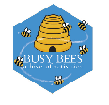
Charity no; 1014692

Upcoming Events & Important dates

Non leavers parent chats
Monday 24th- Friday 28th May- more details to follow

End of term 5;
Friday 28th May

The Preschool will be closed on Monday 7th June 2021
for staff training

School leavers parents chats-
Friday 25th June

School Leavers celebrations- fingers crossed!
Friday 16th July afternoon

If you need any information about funding go to www.childcarechoices.gov.uk
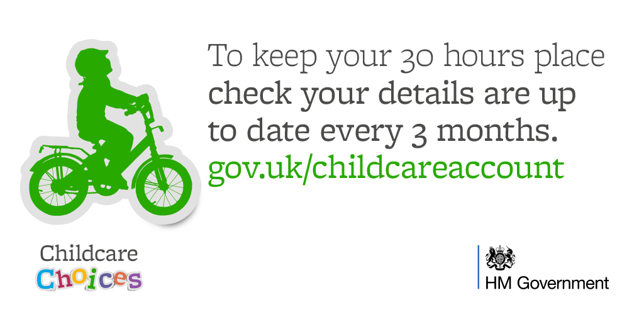

Welcome back everyone, we hope you enjoyed the Easter holidays.
A special welcome to our new families this term.
During the holidays the staff team have made some amazing changes to the outside area ready for a lovely summer term. Although it may be tempting, please ensure your child does not play on equipment at drop off and collection times. We ask that Honey Bees children stay with their parents at these times

Primary School places
You will by now know in which school your child has been offered for September 2019; remember you have to accept to guarantee a place at a school in September, even if you choose to appeal.
Please inform your child’s Key Person or Nikki which school your child is attending in September so that we can start to organise a smooth transition for your child with the relevant schools. You will receive information regarding Information and stay and play sessions for your child in due course from the schools; these will take place during term 6. Please note we are unable to swap your child’s sessions if they coincide with Stay and play sessions at school.

Communication
Communication between home and preschool is essential in the smooth running of the preschool. Inform us of any changes such as mobile phone numbers, addresses etc to we can keep our records up to date and can always get hold of you if we need to.
Please also share any information that may affect your child’s well-being such a change with family circumstances or family bereavement with the manager, so we can offer tailored support to your child if required. All information shared will be in confidence and only discussed with staff on a need to know basis.

General Information
Also…
- With the hope of some warmer weather please ensure your child has a named hat in Preschool. Children are required to have sun-cream applied before coming to Busy Bees. We strongly recommend a once a day sun-cream, alternatively please provide Busy Bees with a high factor sun-cream that can be reapplied at lunchtime.
- Sessions for September; please book your child sessions for September asap. Both 8.30 starts and 4 o’clock club can be used as part of funded hours if booked. Once hours have been claimed for at the beginning of term you are unable to increase hours until the start of the following term- January April or September.
- Therefore, if you are applying for the 30 hour funding for your child for September, you need to apply in June/July and inform the preschool of the 30 hour code and book hours accordingly, before the end of term. If you apply in September the additional funding will be available from January.
- For details of funding including 30 hour criteria go to www.childcarechoices.gov.uk

How you can help us
During your child’s time at Busy Bees you will not be asked to pay for additional activities and experiences, however there are lots of ways you can support the preschool;

Donations of snacks;
- Savoury biscuits such as crackers, digestive rich tea & cheddars
- Fruit & vegetables
- Rice cakes
- Dried fruit
- Cheese
- Large pots of yoghurt
Also, this term donations of soil and plants/herbs would be gratefully received
Cash donation area also welcomed and will be used to towards snacks or resources for the children.
Thank you for your support, it makes a big difference & is really appreciated

